ASERS Publishing
Address: Eugeniu Carada Street, 7, Craiova, 200390
e-mail: apg@aserspublishing.eu
Website: www.aserspublishing.eu

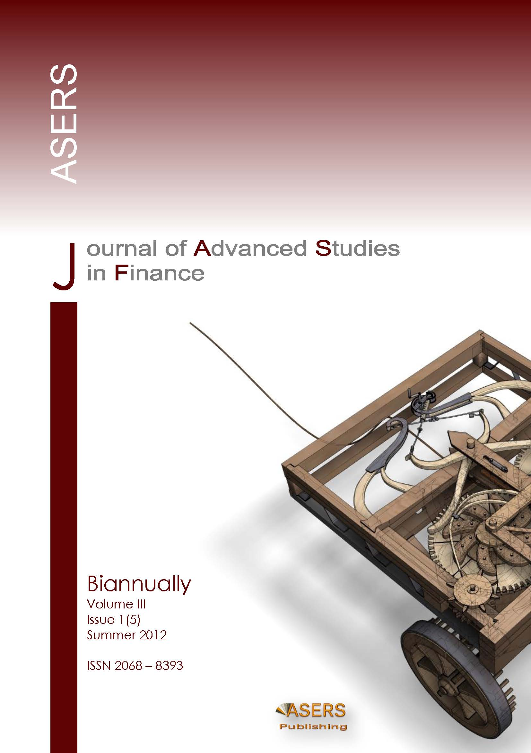

Copyright Transfer Form

to the Publisher of the
Journal of Advanced Studies in Finance

ISSN: 2068-7729 Journal DOI: https://doi.org/10.14505/jasf
http://journals.aserspublishing.eu/jasf jasf@aserspublishing.eu

The Copyright Transfer Form to ASERS Publishing (The Publisher)
This form refers to the manuscript of the paper having the title and the authors as below:
The Title of Paper (hereinafter, "The Paper"): ______________________________________________________________
___________________________________________________________________________________________________
Author(s): #1. First name: ______________________________________________________________________________
Last name ______________________________________________________________________________
#2. First name: ______________________________________________________________________________
Last name ______________________________________________________________________________
The undersigned Author(s) of the above mentioned Paper here transfer any and all copyright-rights in and to The Paper to The Publisher. The Author(s) warrants that The Paper is based on their original work and that the undersigned has the power and authority to make and execute this assignment. It is the author's responsibility to obtain written permission to quote material that has been previously published in any form. The Publisher recognizes the retained rights noted below and grants to the above authors and employers for whom the work performed royalty-free permission to reuse their materials below. Authors may reuse all or portions of the above Paper in other works, excepting the publication of the paper in the same form. Authors may reproduce or authorize others to reproduce the above Paper for the Author's personal use or for internal company use, provided that the source and The Publisher copyright notice are mentioned, that the copies are not used in any way that implies The Publisher endorsement of a product or service of an employer, and that the copies are not offered for sale as such. Authors are permitted to grant third party requests for reprinting, republishing or other types of reuse. The Authors may make limited distribution of all or portions of the above Paper prior to publication if they inform The Publisher of the nature and extent of such limited distribution prior there to. Authors retain all proprietary rights in any process, procedure, or article of manufacture described in The Paper. This agreement becomes null and void if and only if the above paper is not accepted and published by The Publisher, or is with drawn by the author(s) before acceptance by the Publisher.

Authorized Signature (or representative, for ALL AUTHORS): __________________________________________________

Signature of the Employer for whom work was done, if any: ___________________________________________________

Date:_________________

Third Party(ies) Signature(s) (if necessary): __________________________________

